Fall-to-Fall Retention Trends

**SUNY Broome’s** Fall-to-Fall Retention rates are on the rise, jumping from **51.8% in F'20-F'21** to an **impressive 54.6% in F'23-F'24**. This is a **2.8 percentage point increase** over the last three years. This growth highlights the College’s **commitment to student success** and reﬂects the effectiveness of our retention initiatives, such as clarified program pathways, enhanced student support services, and community building through workforce partnerships, while cultivating a **supportive learning environment**.

We’re making **incredible progress** toward achieving **Goal 2 of our Strategic Enrollment Management Plan (SEM)** by 2027! Our mission is clear: **to boost Fall-to-Fall Retention** institutional retention rates to an impressive **57.5%** by 2027.We’re well on our way!

Below are the Fall-to-Fall Retention Rate trends for students that are **First-Time to the College, including**: New First-Time Full-Time and Full-Time Transfer Students (excluding BAP and Non-Pell students)

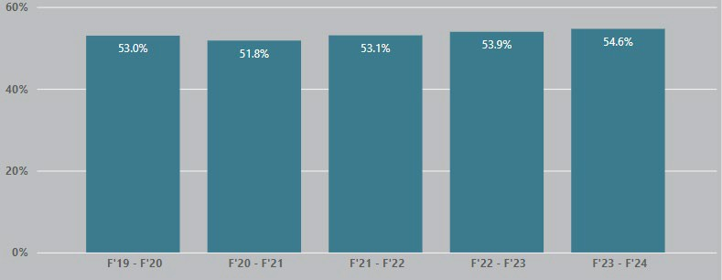

**Closing the Equity Gaps for our Students Who Receive Pell Grants:**

We’re also thrilled to see a boost in Fall-to-Fall Retention rates for our students who receive **Pell Grants**!

**A Pell Grant** is a form of federal ﬁnancial aid in the U.S. awarded to undergraduate students who demonstrate signiﬁcant ﬁnancial need, typically from families earning **under $60,000 annually**, with most recipients coming from families earning **less than $30,000**. **Eligibility** is determined through the **FAFSA**, prioritizing low-income students who have not yet earned a bachelor's or professional degree. Unlike loans, Pell Grants do not need to be repaid, making them a crucial resource for students pursuing higher education.

**As can be seen in the below graph, in F'20-F'21, the retention rate for** New First-Time Full-Time and Full-Time Transfer Students (excluding BAP and Non-Pell students) and who are **receiving Pell Grants was 48.6%**, **and now, in F'23-F'24, it has increased to 50.8%**, **an increase of 2.2 percentage points!** This upward trend is a testament to our **ongoing efforts to support student success** for our most economically disadvantaged students. These results highlight the College’s commitment to **closing the equity gap** for Pell-eligible students, ensuring that all students have the **opportunity to thrive and succeed.**

Below are the Fall-to-Fall Retention Rate trends for students **who are receiving Pell Grants** and that are **First-Time to the College**:

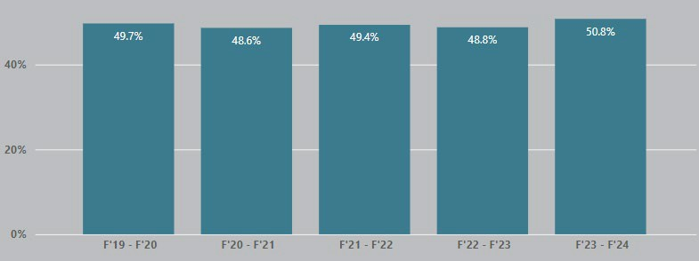

Curious about other **details?** Dive into our [**Student Retention Dashboard**](https://mycollege.sunybroome.edu/web/institutional-effectiveness/dashboard)on the **Institutional Effectiveness** webpage, where you can explore retention trends by **full-time/part-time status, gender, race/ethnicity, division, and major.** It’s packed with **insights** to help us better understand and support our student community!